A suggested homepage structure

Welcoming images

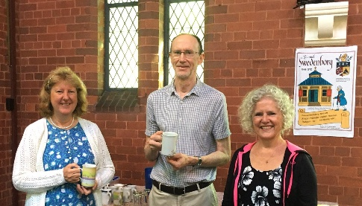 | 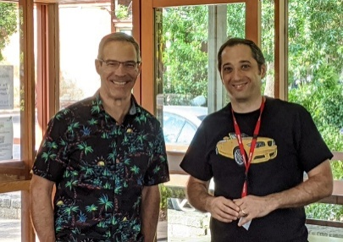 | 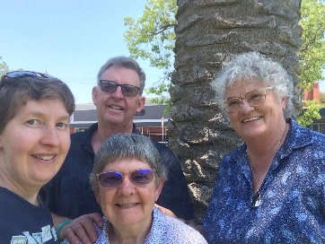
Welcome message
Welcome to the Roseville New Church, a community serving the Lord and encouraging personal development.

Step into a space where wisdom and compassion intersect, where seekers find a richer interpretation of the Bible, a deeper understanding of Christianity, and a precious sense of the Divine presence in the world. We embrace individuals from all walks of life, inviting you to join us on a journey of spiritual growth and discovery.

We’re here to help people grow closer to the Lord God Jesus Christ, and so find happiness, peace and meaning in their lives.

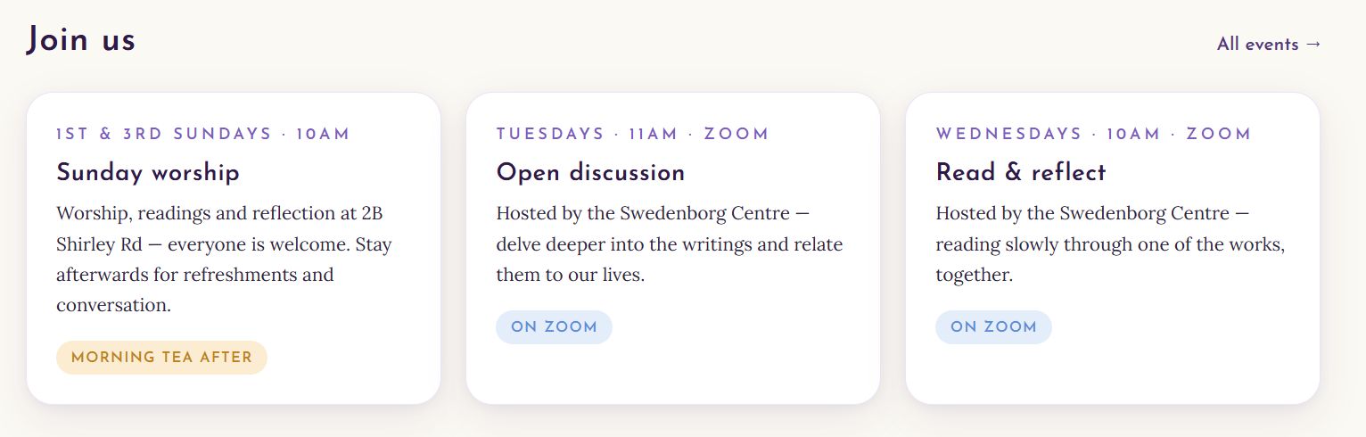
Visiting us

Refer to the Join us docx for expansion to webpages.

In the footer have a link to a CONTACT US webpage
4 Shirley Rd, Roseville NSW 2069, Australia
Church Office: 02 9416 7026
pastor@rosevillenewchurch.com.au

Use
https://hurstvillenewchurch.com/about/contact-us/
as a model

